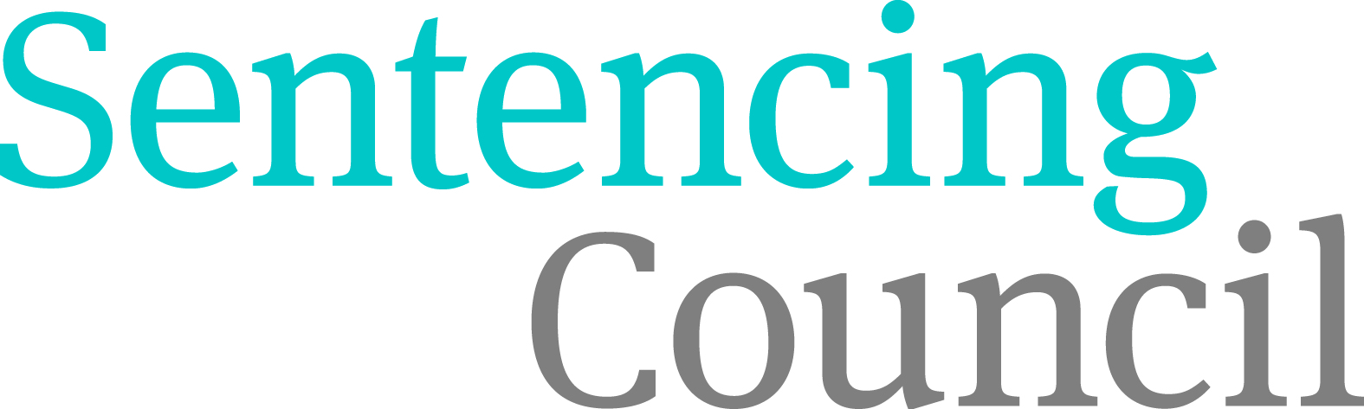

Confidence and Communications Sub-group meeting
7 December 2015, 9 – 10:30am
By phone: Dial 08444 737373 PIN 021323

Agenda

Intro (MC - 2 mins)

- Impact of spending restrictions on comms/risks and budget (HS – 10 mins)

- Action log (HS – 10 mins)
Paper 1: 2015-12-07 Action log DEC

- Victims (NM - 15 mins)
- update on progress

- Digital (HS - 20 mins)
Paper 2: 2015-12-07 Digital paper
- web stats and online survey
- members' area document store
- further developments on the online MCSG
- Crown Court guidelines

- Media handling (NM - 30 mins)
Paper 3: 2015-12-07 Forthcoming guidelines
- Looking forward to: allocation, imposition, robbery and guilty pleas

AOB (All - 3 mins)

